Bahria University,

Karachi Campus



COURSE: CSC-221 DATA STRUCTURES AND ALGORITHM

TERM: FALL 2020, CLASS: BSE- 3 (A)

Submitted By:

_______________________________________________

(ADIL WAHEED) (65190)

Submitted To:

Engr. Dr. Farah/ Engr. Ramshaa

Signed Remarks: Score:

INDEX

|  |  |  |  |  |
| --- | --- | --- | --- | --- |
| SNO | DATE | LAB NO | LAB OBJECTIVE | SIGN |
| 01 | 1-10-2020 | 01 | ONE AND TWO DIMENSIONAL ARRAY |  |
|  |  |  |  |  |
|  |  |  |  |  |
|  |  |  |  |  |
|  |  |  |  |  |
|  |  |  |  |  |
|  |  |  |  |  |
|  |  |  |  |  |
|  |  |  |  |  |
|  |  |  |  |  |
|  |  |  |  |  |
|  |  |  |  |  |
|  |  |  |  |  |
| SNO | DATE | LAB NO | LAB OBJECTIVE | SIGN |
|  |  |  |  |  |
|  |  |  |  |  |
|  |  |  |  |  |
|  |  |  |  |  |
|  |  |  |  |  |
|  |  |  |  |  |
|  |  |  |  |  |
|  |  |  |  |  |
|  |  |  |  |  |
|  |  |  |  |  |
|  |  |  |  |  |

Bahria University,

Karachi Campus



LAB EXPERIMENT NO.

___**01**____

LIST OF TASKS

|  |  |
| --- | --- |
| TASK NO | OBJECTIVE |
| Q | Create an array of length 10 of integers. Values ranging from 1 to 50. |
| 1 | Find all pair of elements whose sum is 25. |
| 2 | Find the number of elements of A which are even, and the number of elements of A which are odd. |
| 3 | Write a procedure which finds the average of the value of A. |
| 4 | Write a procedure which adds an element in an array at a given index. Take the value to add and the index from the user by using Shift down technique |
| 5 | Write a procedure which looks for 2 numbers 45 and 14 in an array and delete them if they are present in the array by using Shift up technique. |
| 6 | Write a program which input 2 matrix of user defined rows and columns and perform following operation  a. Display/Print as a Matrix  b. Addition of Matrix  c. Subtraction of Matrix  d. matrix multiplication  e. Determinant  f. Inverse |

Submitted On:

____________

(Date: 09/10/20)

**Task No. :** Create an array of length 10 of integers. Values ranging from 1 to 50.

**Solution:**

int[] array = new int[10];

for (int i = 0; i < array.Length; i++)

{

array[i] = i * 5;

}

for (int i = 0; i < array.Length; i++)

{

//array[0] = 1;

Console.WriteLine("Array={0}", array[i]);

}

**Output:**

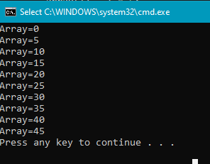

**Task No. 1:** Find all pair of elements whose sum is 25.

**Solution:**

static void pairs_value(int[] inputArray, int inputNumber)

{

Console.WriteLine("Pairs of elements and their sum : ");

for (int i = 0; i < inputArray.Length; i++)

{

for (int j = i + 1; j < inputArray.Length; j++)

{

if (inputArray[i] + inputArray[j] == inputNumber)

{

Console.WriteLine(inputArray[i] + " + " + inputArray[j] + " = " + inputNumber);

}

}

}

}

static void Main(string[] args)

{

pairs_value(new int[] { 2, 7, 4, -5, 21 }, 25);

}

**Output:**

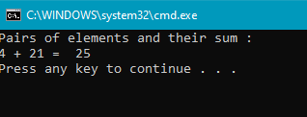

**Task No. 2:** Find the number of elements of A which are even, and the number of elements of A which are odd.

**Solution:**

Console.WriteLine("Enter a number of array we used");

int n = Convert.ToInt32(Console.ReadLine());

int[] A = new int[n] ;

for (int i = 0; i < A.Length; i++)

{

Console.WriteLine("Enter a Number of Array[{0}]", i);

A[i] = Convert.ToInt32(Console.ReadLine());

}

Console.WriteLine("ODD VALUES");

for (int i = 0; i < A.Length; i++)

{

if (A[i] % 2 == 0)

{

Console.Write("{0} , ", A[i]);

}

}

Console.WriteLine();

Console.WriteLine("EVEN VALUES");

for (int i = 0; i < A.Length; i++)

{

if (A[i]%2!=0)

{

Console.Write("{0} ,",A[i]);

}

}

Console.WriteLine();

**Output:**

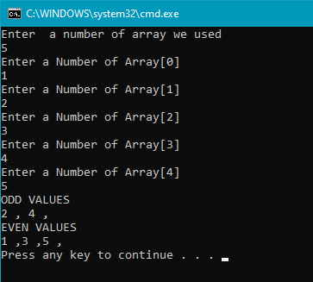

**Task No. 3:** Write a procedure which finds the average of the value of A.

**Solution:**

Console.WriteLine("Enter a number of array we used");

int n = Convert.ToInt32(Console.ReadLine());

int[] A = new int[n];

int sum=0;

int average;

for (int i = 0; i < A.Length; i++)

{

Console.WriteLine("Enter Number A[{0}]",i);

A[i] = Convert.ToInt32(Console.ReadLine());

sum += A[i];

}

average = sum / n;

Console.WriteLine("Average:{0}",average);

**Output:** 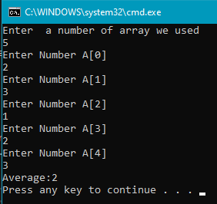

**Task No. 4:** Write a procedure which adds an element in an array at a given index. Take the value to add and the index from the user by using Shift down technique.

**Solution:**

int i, n, x, p;

int[] arr1 = new int[10];

arr1[0] = 1;

arr1[1] = 2;

arr1[2] = 3;

arr1[3] = 4;

n = 4;

Console.Write("Input the value to be inserted : ");

x = Convert.ToInt32(Console.ReadLine());

Console.Write("Input the Position, where the value to be inserted :");

p = Convert.ToInt32(Console.ReadLine());

Console.Write("The current list of the array :\n");

for ( i = 0; i <n; i++)

{

Console.WriteLine("{0}", arr1[i]);

}

/* Move all data at right side of the array */

for ( i = n; i >= p; i--)

{

arr1[i] = arr1[i - 1];

arr1[p - 1] = x;

}

/////* insert value at given position */

Console.Write("\n\nAfter Insert the element the new list is :\n");

for ( i = 0; i <= n; i++)

{

Console.WriteLine("{0}",arr1[i]);

}

Console.Write("\n\n");

**Output:**

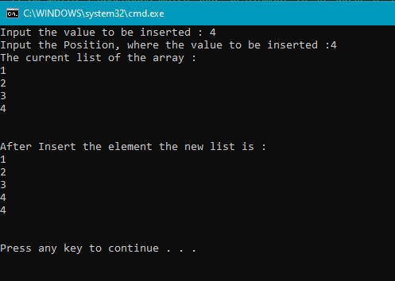

**Task No. 5:** Write a procedure which looks for 2 numbers 45 and 14 in an array and delete them if they are present in the array by using Shift up technique.

**Solution:**

int n1 = 45, n2 = 14;

int[] arr1 = new int[10];

Console.WriteLine("Enter the value between 1 to 50");

for (int i = 0; i < arr1.Length; i++)

{

Console.Write("Element[{0}]=",i);

arr1[i] = Convert.ToInt32(Console.ReadLine());

}

Console.Write("The Uptadet list of the array :\n");

for (int i = 0; i < arr1.Length; i++)

{

if ((arr1[i] == n1) || (arr1[i] == n2))

{

arr1 = arr1.Except(new int[] { 14 }).ToArray();

arr1 = arr1.Except(new int[] { 45 }).ToArray();

}

}

for (int i = 0; i <arr1.Length; i++)

{

Console.WriteLine("Element[{0}]={1}", i, arr1[i]);

}

Console.Write("\n\n");

**Output:**

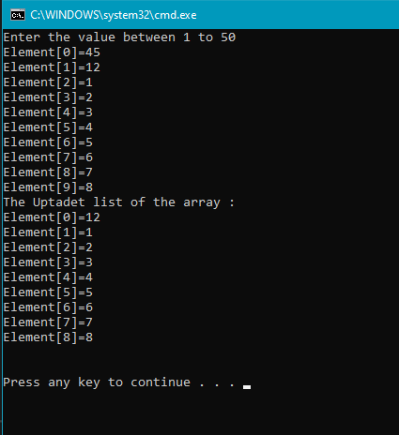

**2D ARRAYS**

**Task No. 5:** Write a program which input 2 matrix of user defined rows and columns and perform following operation

a. Display/Print as a Matrix

b. Addition of Matrix

c. Subtraction of Matrix

d. matrix multiplication

e. Determinant

f. Inverse

**Solution:**

**int n;**

**char o;**

**do**

**{**

**Console.WriteLine("Which you want to perform an operation ");**

**Console.WriteLine(" 1) Display / Print as a Matrix\n 2) Addition of Matrix \n 3) Subtraction of Matrix \n 4) matrix multiplication\n 5)Determinant\n 6)Inverse");**

**n = Convert.ToInt32(Console.ReadLine());**

**if (n == 1)**

**{**

**Console.WriteLine("===DISPLAY MATRIXS===");**

**Console.WriteLine("enter the matric row and colomn");**

**Console.WriteLine("enter the rows");**

**int row = Convert.ToInt32(Console.ReadLine());**

**Console.WriteLine("enter the colomn");**

**int col = Convert.ToInt32(Console.ReadLine());**

**int[,] matric1 = new int[row, col];**

**for (int i = 0; i < matric1.GetLength(0); i++)**

**{**

**for (int j = 0; j < matric1.GetLength(1); j++)**

**{**

**Console.WriteLine("enter the values of matrix {0},{1}", i, j);**

**matric1[i, j] = Convert.ToInt32(Console.ReadLine());**

**}**

**}**

**for (int i = 0; i < matric1.GetLength(0); i++)**

**{**

**for (int j = 0; j < matric1.GetLength(1); j++)**

**{**

**Console.Write(" " + matric1[i, j] + " ");**

**}**

**Console.WriteLine();**

**}**

**int[,] matric2 = new int[row, col];**

**for (int i = 0; i < matric2.GetLength(0); i++)**

**{**

**for (int j = 0; j < matric2.GetLength(1); j++)**

**{**

**Console.WriteLine("enter the values of matrix {0},{1}", i, j);**

**matric2[i, j] = Convert.ToInt32(Console.ReadLine());**

**}**

**}**

**for (int i = 0; i < matric2.GetLength(0); i++)**

**{**

**for (int j = 0; j < matric2.GetLength(1); j++)**

**{**

**Console.Write(" " + matric2[i, j] + " ");**

**}**

**Console.WriteLine();**

**}**

**}**

**else if (n == 2)**

**{**

**Console.WriteLine("=====ADDITION OF MATRIX======");**

**Console.WriteLine("enter the matric row and colomn");**

**Console.WriteLine("enter the rows");**

**int row = Convert.ToInt32(Console.ReadLine());**

**Console.WriteLine("enter the colomn");**

**int col = Convert.ToInt32(Console.ReadLine());**

**int[,] matric1 = new int[row, col];**

**for (int i = 0; i < matric1.GetLength(0); i++)**

**{**

**for (int j = 0; j < matric1.GetLength(1); j++)**

**{**

**Console.WriteLine("enter the values of matrix {0},{1}", i, j);**

**matric1[i, j] = Convert.ToInt32(Console.ReadLine());**

**}**

**}**

**for (int i = 0; i < matric1.GetLength(0); i++)**

**{**

**for (int j = 0; j < matric1.GetLength(1); j++)**

**{**

**Console.Write(" " + matric1[i, j] + " ");**

**}**

**Console.WriteLine();**

**}**

**int[,] matric2 = new int[row, col];**

**for (int i = 0; i < matric2.GetLength(0); i++)**

**{**

**for (int j = 0; j < matric2.GetLength(1); j++)**

**{**

**Console.WriteLine("enter the values of matrix {0},{1}", i, j);**

**matric2[i, j] = Convert.ToInt32(Console.ReadLine());**

**}**

**}**

**for (int i = 0; i < matric2.GetLength(0); i++)**

**{**

**for (int j = 0; j < matric2.GetLength(1); j++)**

**{**

**Console.Write(" " + matric2[i, j] + " ");**

**}**

**Console.WriteLine();**

**}**

**int[,] matric3 = new int[row, col];**

**for (int i = 0; i < row; i++)**

**{**

**for (int j = 0; j < col; j++)**

**{**

**matric3[i, j] = matric1[i, j] + matric2[i, j];**

**}**

**}**

**Console.WriteLine("RESULT OF ADDITION MATRICES");**

**for (int i = 0; i < row; i++)**

**{**

**for (int j = 0; j < col; j++)**

**{**

**Console.Write(" " + matric3[i, j] + " ");**

**}**

**Console.WriteLine();**

**}**

**}**

**else if (n == 3)**

**{**

**Console.WriteLine("=====SUBTRACTION OF MATRIX======");**

**Console.WriteLine("enter the matric row and colomn");**

**Console.WriteLine("enter the rows");**

**int row = Convert.ToInt32(Console.ReadLine());**

**Console.WriteLine("enter the colomn");**

**int col = Convert.ToInt32(Console.ReadLine());**

**int[,] matric1 = new int[row, col];**

**for (int i = 0; i < matric1.GetLength(0); i++)**

**{**

**for (int j = 0; j < matric1.GetLength(1); j++)**

**{**

**Console.WriteLine("enter the values of matrix {0},{1}", i, j);**

**matric1[i, j] = Convert.ToInt32(Console.ReadLine());**

**}**

**}**

**for (int i = 0; i < matric1.GetLength(0); i++)**

**{**

**for (int j = 0; j < matric1.GetLength(1); j++)**

**{**

**Console.Write(" " + matric1[i, j] + " ");**

**}**

**Console.WriteLine();**

**}**

**int[,] matric2 = new int[row, col];**

**for (int i = 0; i < matric2.GetLength(0); i++)**

**{**

**for (int j = 0; j < matric2.GetLength(1); j++)**

**{**

**Console.WriteLine("enter the values of matrix {0},{1}", i, j);**

**matric2[i, j] = Convert.ToInt32(Console.ReadLine());**

**}**

**}**

**for (int i = 0; i < matric2.GetLength(0); i++)**

**{**

**for (int j = 0; j < matric2.GetLength(1); j++)**

**{**

**Console.Write(" " + matric2[i, j] + " ");**

**}**

**Console.WriteLine();**

**}**

**int[,] matric3 = new int[row, col];**

**for (int i = 0; i < row; i++)**

**{**

**for (int j = 0; j < col; j++)**

**{**

**matric3[i, j] = matric1[i, j] - matric2[i, j];**

**}**

**}**

**Console.WriteLine("RESULT OF SUBTRACTION MATRICES");**

**for (int i = 0; i < row; i++)**

**{**

**for (int j = 0; j < col; j++)**

**{**

**Console.Write(" " + matric3[i, j] + " ");**

**}**

**Console.WriteLine();**

**}**

**}**

**else if (n == 4)**

**{**

**Console.WriteLine("==========MAULTIPLICATION MATRICES=========");**

**Console.WriteLine("enter the matric row and colomn");**

**Console.WriteLine("enter the rows");**

**int row = Convert.ToInt32(Console.ReadLine());**

**Console.WriteLine("enter the colomn");**

**int col = Convert.ToInt32(Console.ReadLine());**

**int[,] matric1 = new int[row, col];**

**int[,] matric3 = new int[row, col];**

**for (int i = 0; i < matric1.GetLength(0); i++)**

**{**

**for (int j = 0; j < matric1.GetLength(1); j++)**

**{**

**Console.WriteLine("enter the values of matrix {0},{1}", i, j);**

**matric1[i, j] = Convert.ToInt32(Console.ReadLine());**

**}**

**}**

**for (int i = 0; i < matric1.GetLength(0); i++)**

**{**

**for (int j = 0; j < matric1.GetLength(1); j++)**

**{**

**Console.Write(" " + matric1[i, j] + " ");**

**}**

**Console.WriteLine();**

**}**

**int[,] matric2 = new int[row, col];**

**for (int i = 0; i < matric2.GetLength(0); i++)**

**{**

**for (int j = 0; j < matric2.GetLength(1); j++)**

**{**

**Console.WriteLine("enter the values of matrix {0},{1}", i, j);**

**matric2[i, j] = Convert.ToInt32(Console.ReadLine());**

**}**

**}**

**for (int i = 0; i < matric2.GetLength(0); i++)**

**{**

**for (int j = 0; j < matric2.GetLength(1); j++)**

**{**

**Console.Write(" " + matric2[i, j] + " ");**

**}**

**Console.WriteLine();**

**}**

**for (int i = 0; i < row; i++)**

**{**

**for (int j = 0; j < col; j++)**

**{**

**matric3[i, j] = 0;**

**for (int k = 0; k < 2; k++)**

**{**

**matric3[i, j] += matric1[i, k] * matric2[k, j];**

**}**

**}**

**}**

**Console.WriteLine("RESULT OF MATRIX MULTIPLCATION");**

**for (int i = 0; i < row; i++)**

**{**

**for (int j = 0; j < col; j++)**

**{**

**Console.Write(" " + matric3[i, j] + " ");**

**}**

**Console.WriteLine();**

**}**

**}**

**else if (n==5)**

**{**

**Console.WriteLine("=====DETERMINENT OF MATRIX======");**

**Console.WriteLine("enter the matric row and colomn");**

**int[,] matric1 = new int[2, 2];**

**for (int i = 0; i < matric1.GetLength(0); i++)**

**{**

**for (int j = 0; j < matric1.GetLength(1); j++)**

**{**

**Console.WriteLine("enter the values of matrix {0},{1}", i, j);**

**matric1[i, j] = Convert.ToInt32(Console.ReadLine());**

**}**

**}**

**for (int i = 0; i < matric1.GetLength(0); i++)**

**{**

**for (int j = 0; j < matric1.GetLength(1); j++)**

**{**

**Console.Write(" " + matric1[i, j] + " ");**

**}**

**Console.WriteLine();**

**}**

**int[,] matric3 = new int[2, 2];**

**int ans=0;**

**for (int i = 0; i < 2; i++)**

**{**

**for (int j = 0; j < 2; j++)**

**{**

**ans = matric1[0, 0] * matric1[1, 1] - matric1[0, 1] * matric1[1, 0];**

**}**

**}**

**Console.WriteLine("RESULT OF DETERMINENT MATRICES");**

**Console.WriteLine("ANS=={0}",ans);**

**}**

**else if (n==6)**

**{**

//a inverse A/det.Ainverse

Console.WriteLine("=====INVERSE OF MATRIX======");

Console.WriteLine("enter the matric row and colomn");

double[,] matric1 = new double[2, 2];

for (int i = 0; i < matric1.GetLength(0); i++)

{

for (int j = 0; j < matric1.GetLength(1); j++)

{

Console.WriteLine("enter the values of matrix {0},{1}", i, j);

matric1[i, j] = Convert.ToDouble(Console.ReadLine());

}

}

for (int i = 0; i < matric1.GetLength(0); i++)

{

for (int j = 0; j < matric1.GetLength(1); j++)

{

Console.Write(" " + matric1[i, j] + " ");

}

Console.WriteLine();

}

Console.WriteLine("=========INVERSE OF MATRIC======");

double temp;

double[,] matric3 = new double[2, 2];

double ans = 0;

for (int i = 0; i < 2; i++)

{

for (int j = 0; j < 2; j++)

{

ans = matric1[0, 0] * matric1[1, 1] - matric1[0, 1] * matric1[1, 0];

}

}

for (int i = 0; i < 2; i++)

{

for (int j = 0; j < 2; j++)

{

temp = matric1[0, 0];

matric1[0, 0] = matric1[1, 1];

matric1[1, 1] = temp;

matric1[1, 0] = (-1) * (matric1[1, 0]);

Console.Write(" " + matric1[i, j] + " ");

matric1[0, 1] = (-1) * (matric1[0, 1]);

temp = matric1[0, 0];

matric1[0, 0] = matric1[1, 1];

matric1[1, 1] = temp;

}

Console.WriteLine();

}

try

{

for (int i = 0; i < 2; i++)

{

for (int j = 0; j < 2; j++)

{

if (i==0&&j == 0)

{

matric3[0, 0] = matric1[0, 0] / ans;

// Console.WriteLine("[{0},{1}]=", i, j);

}

else if (i == 1 && j == 0)

{

matric3[1, 0] = matric1[1, 0] / ans;

// Console.WriteLine("[{0},{1}]=", i, j);

}

else if (i==0&&j == 1)

{

matric3[0, 1] = matric1[0, 1] / ans;

// Console.WriteLine("[{0},{1}]=", i, j);

}

else if (i == 1 && j == 1)

{

matric3[1, 1] = matric1[1, 1] / ans;

// Console.WriteLine("[{0},{1}]=", i, j);

}

}

}

}

catch (Exception e)

{

Console.WriteLine(e.Message);

}

Console.WriteLine("RESULT OF DETERMINENT MATRICES");

Console.WriteLine("Determinent=={0}", ans);

Console.WriteLine("Inverse");

for (int i = 0; i < 2; i++)

{

for (int j = 0; j < 2; j++)

{

temp = matric3[0, 0];

matric3[0, 0] = matric3[1, 1];

matric3[1, 1] = temp;

matric3[1, 0] = (-1) * (matric3[1, 0]);

Console.Write(" " + matric3[i, j] + " ");

matric3[0, 1] = (-1) * (matric3[0, 1]);

temp = matric3[0, 0];

matric3[0, 0] = matric3[1, 1];

matric3[1, 1] = temp;

}

Console.WriteLine();

}

**}**

**else**

**{**

**Console.WriteLine("PLEASE ENTER NUMBER BETWEEN 1 TO 6 !!!! INVALID NUMBER!!!!!!!!!!!!");**

**}**

**Console.WriteLine("do you want to perform another operation y/n");**

**o = Convert.ToChar(Console.ReadLine());**

**} while (o =='y'||o=='Y');**

**Output:**

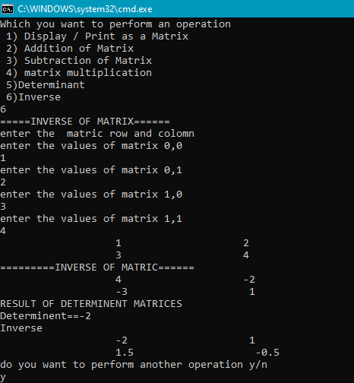

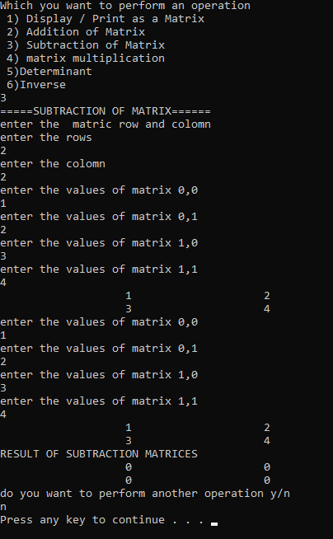

Bahria University,

Karachi Campus



COURSE: CSC-221 DATA STRUCTURES AND ALGORITHM

TERM: FALL 2020, CLASS: BSE- 3 (A)

Submitted By:

_______________________________________________

(ADIL WAHEED) (65190)

Submitted To:

Engr. Dr. Farah/ Engr. Ramshaa

Signed Remarks: Score:

INDEX

|  |  |  |  |  |
| --- | --- | --- | --- | --- |
| SNO | DATE | LAB NO | LAB OBJECTIVE | SIGN |
| 01 | 1-10-2020 | 01 | ONE AND TWO DIMENSIONAL ARRAY |  |
| 02 | 09-10-20 |  | Linear Search & Sorting Algorithms |  |
|  |  |  |  |  |
|  |  |  |  |  |
|  |  |  |  |  |
|  |  |  |  |  |
|  |  |  |  |  |
|  |  |  |  |  |
|  |  |  |  |  |
|  |  |  |  |  |
|  |  |  |  |  |
|  |  |  |  |  |
|  |  |  |  |  |
| SNO | DATE | LAB NO | LAB OBJECTIVE | SIGN |
|  |  |  |  |  |
|  |  |  |  |  |
|  |  |  |  |  |
|  |  |  |  |  |
|  |  |  |  |  |
|  |  |  |  |  |
|  |  |  |  |  |
|  |  |  |  |  |
|  |  |  |  |  |
|  |  |  |  |  |
|  |  |  |  |  |
|  |  |  |  |  |

Bahria University,

Karachi Campus



LAB EXPERIMENT NO.

___**2**____

LIST OF TASKS

|  |  |
| --- | --- |
| TASK NO | OBJECTIVE |
| 01 | Which type of sorting you want to apply? Create a menu having the following options:   * 1. Bubble Sort Method   2. Selection Sort Method   3. Insertion Sort Method   Implement using methods. |
| 02 | Implement Selection sort and print string array data in descending order. |
| 03 | You have to write a program which take input from the user and place the value on correct location in ascending order. |
| 04 | Write a program which take N numbers of grocery items from user along with their price. Your main task is to display the items in sorted format. Then allow user to search for any of the item from that list by using name of the item. |
|  |  |
|  |  |
|  |  |

Submitted On:

____________

(Date: 09/10/20)

**Task No. 1:** Which type of sorting you want to apply? Create a menu having the following options:

1. Bubble Sort Method
2. Selection Sort Method
3. Insertion Sort Method

Implement using methods.

**Solution:**

string o;

do

{

Console.WriteLine("Which type of sorting you want to apply?");

Console.WriteLine("1)Bubble Sort Method\n2)Selection Sort Method\n3)Insertion Sort Method");

int a;

a =(Convert.ToInt32(Console.ReadLine()));

if (a == 1)

{

int[] array = new int[5];

int n = array.Length;

Console.WriteLine("====Bubble Sort=====");

Console.WriteLine("Enter Value only 5 index is avaliable ");

for (int i = 0; i < n; i++)

{

Console.WriteLine("Enter Value of {0}", i + 1);

array[i] = Convert.ToInt32(Console.ReadLine());

}

Console.WriteLine("user enter value:");

for (int i = 0; i < n; i++)

{

Console.Write("{0} ,", array[i]);

}

int k;

for (int m = n; m >= 0; m--)

{

for (int i = 0; i < n - 1; i++)

{

k = i + 1;

if (array[i] > array[k])

{

int temp;

temp = array[i];

array[i] = array[k];

array[k] = temp;

}

}

}

Console.WriteLine();

Console.WriteLine("sorted value:");

for (int i = 0; i < n; i++)

{

Console.Write("{0} ,", array[i]);

}

Console.WriteLine();

}

else if (a == 2)

{

int[] array = new int[5];

int n = array.Length;

Console.WriteLine("===Selection Sort====");

Console.WriteLine("Enter Value only 5 index is avaliable ");

for (int i = 0; i < n; i++)

{

Console.WriteLine("Enter Value of {0}", i + 1);

array[i] = Convert.ToInt32(Console.ReadLine());

}

Console.WriteLine("user enter value:");

for (int i = 0; i < n; i++)

{

Console.Write("{0} ,", array[i]);

}

int temp, smallest;

for (int i = 0; i < n - 1; i++)

{

smallest = i;

for (int j = i + 1; j < n; j++)

{

if (array[j] < array[smallest])

{

smallest = j;

}

}

temp = array[smallest];

array[smallest] = array[i];

array[i] = temp;

}

Console.WriteLine();

Console.WriteLine("sorted value:");

for (int i = 0; i < n; i++)

{

Console.Write("{0} ,", array[i]);

}

Console.WriteLine();

}

else if (a == 3)

{

int[] array = new int[5];

int n = array.Length;

Console.WriteLine("===Insertion Sort====");

Console.WriteLine("Enter Value only 5 index is avaliable ");

for (int i = 0; i < n; i++)

{

Console.WriteLine("Enter Value of {0}", i + 1);

array[i] = Convert.ToInt32(Console.ReadLine());

}

Console.WriteLine("user enter value:");

for (int i = 0; i < n; i++)

{

Console.Write("{0} ,", array[i]);

}

for (int i = 0; i < n - 1; i++)

{

for (int j = i + 1; j > 0; j--)

{

if (array[j - 1] > array[j])

{

int temp = array[j - 1];

array[j - 1] = array[j];

array[j] = temp;

}

}

}

Console.WriteLine();

Console.WriteLine("sorted value:");

for (int k = 0; k < n; k++)

{

Console.Write("{0} ,", array[k]);

}

Console.WriteLine();

}

else

{

Console.WriteLine("Please enter value from 1 to 3!!!");

}

Console.WriteLine("Do you want to another perform another operation y/n");

o = Convert.ToString(Console.ReadLine());

} while (o == "y" || o == "Y");

**Output:**

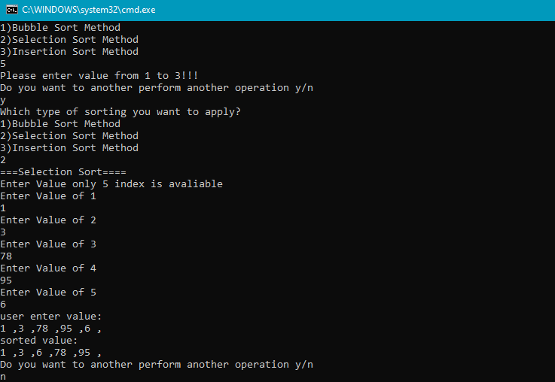

**Task No. 2:** Implement Selection sort and print string array data in descending order

**Solution:**

Console.WriteLine("which number of array is used?");

int n = Convert.ToInt32(Console.ReadLine());

int[] array = new int [n];

for (int i = 0; i < n; i++)

{

Console.WriteLine("Enter Value of {0}", i + 1);

array[i] = Convert.ToInt32(Console.ReadLine());

}

Console.WriteLine("user enter value:");

for (int i = 0; i < n; i++)

{

Console.Write("{0} ,", array[i]);

}

int temp, largest;

for (int i = 0; i < n - 1; i++)

{

largest = i;

for (int j = i + 1; j < n; j++)

{

if (array[largest] < array[j])

{

largest = j;

}

}

temp = array[largest];

array[largest] = array[i];

array[i] = temp;

}

Console.WriteLine();

Console.WriteLine("sorted value,Desending order:");

for (int k = 0; k < n; k++)

{

Console.Write("{0} ,", array[k]);

}

Console.WriteLine();

**Output:**

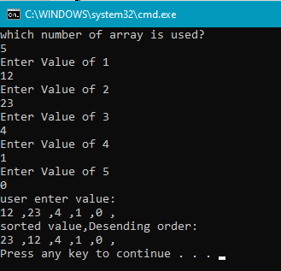

**Task No. 3:** You have to write a program which take input from the user and place the value on correct location in ascending order.

**Solution:**

int n;

Console.WriteLine("Enter a number");

n = Convert.ToInt32(Console.ReadLine());

int[] array = {3,2,5,4,8,n};

Console.WriteLine("values:");

for (int i = 0; i < array.Length-1; i++)

{

Console.Write("{0} ,", array[i]);

}

Console.WriteLine();

int k;

for (int m = array.Length; m >= 0; m--)

{

for (int i = 0; i < array.Length - 1; i++)

{

k = i + 1;

if (array[i] > array[k])

{

int temp;

temp = array[i];

array[i] = array[k];

array[k] = temp;

}

}

}

Console.WriteLine();

Console.WriteLine("ASCENDING ORDER:");

for (int i = 0; i < array.Length; i++)

{

Console.Write("{0} ,", array[i]);

}

Console.WriteLine();

**Output:**

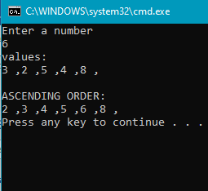

**Task No. 5:** Write a program which take N numbers of grocery items from user along with their price. Your main task is to display the items in sorted format. Then allow user to search for any of the item from that list by using name of the item.

**Solution:**

class Program

{

static void Insertion_sort(string[,] array)

{

string temp, name;

for(int i = 0; i < array.Length/2 - 1; i++)

{

for( int j = i+1; j > 0; j--)

{

float p1 = float.Parse(array[j-1,1]);

float p2 = float.Parse(array[j , 1]);

if(p1 > p2)

{

temp = array[j - 1, 1];

array[j-1 , 1] = array[j,1];

array[j, 1] = temp;

name = array[j-1, 0] ;

array[j - 1, 0] = array[j, 0];

array[j, 0] = name;

}

}

}

display(array);

}

static void display(string[,] array)

{

for (int i = 0; i < array.Length/2 ; i++)

{

Console.WriteLine( );

Console.WriteLine(" item name : \t"+ array[i,0] );

Console.WriteLine(" price : \t" + array[i, 1]);

Console.WriteLine();

}

}

static void selecting(String[,] array)

{

Console.Write(" want to find any item :");

char ans = Convert.ToChar(Console.ReadLine());

if (ans == 'Y'|| ans == 'y')

{ do

{

Console.Write(" enter item name : \t");

string name = Console.ReadLine();

for (int i = 0; i < array.Length / 2; i++)

{

if (name.ToLower() == array[i, 0])

{

Console.WriteLine();

Console.WriteLine("Item Found at {0}", i);

Console.WriteLine(" item name : \t" + array[i, 0]);

Console.WriteLine(" price : \t" + array[i, 1]);

Console.WriteLine();

}

}

Console.Write(" want to find any item :");

ans = Convert.ToChar(Console.ReadLine());

} while (ans == 'y' || ans == 'Y');

}

}

static void Main(string[] args)

{

Console.Write(" please enter the number of grocery items you want to enter in list : ");

int n = Convert.ToInt32(Console.ReadLine());

string[,] list = new string[n, 2];

for( int i = 0; i < list.Length/2; i++)

{

Console.Write(" enter name of item : ");

list[i, 0] = Console.ReadLine();

Console.Write(" enter price of item : ");

list[i, 1] = Console.ReadLine();

}

Insertion_sort(list);

selecting(list);

}

}

}

**Output:**

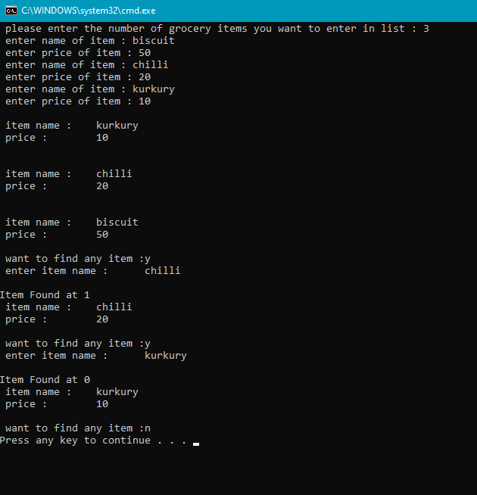

Bahria University,

Karachi Campus



COURSE: CSC-221 DATA STRUCTURES AND ALGORITHM

TERM: FALL 2020, CLASS: BSE- 3 (A)

Submitted By:

_______________________________________________

(ADIL WAHEED) (65190)

Submitted To:

Engr. Dr. Farah/ Engr. Ramshaa

Signed Remarks: Score:

INDEX

|  |  |  |  |  |
| --- | --- | --- | --- | --- |
| SNO | DATE | LAB NO | LAB OBJECTIVE | SIGN |
| 01 | 1-10-2020 | 01 | ONE AND TWO DIMENSIONAL ARRAY |  |
| 02 | 09-10-20 | 02 | Linear Search & Sorting Algorithms |  |
| 03 | 13-10-20 | 03 | Recusrion |  |
|  |  |  |  |  |
|  |  |  |  |  |
|  |  |  |  |  |
|  |  |  |  |  |
|  |  |  |  |  |
|  |  |  |  |  |
|  |  |  |  |  |
|  |  |  |  |  |
|  |  |  |  |  |
|  |  |  |  |  |
| SNO | DATE | LAB NO | LAB OBJECTIVE | SIGN |
|  |  |  |  |  |
|  |  |  |  |  |
|  |  |  |  |  |
|  |  |  |  |  |
|  |  |  |  |  |
|  |  |  |  |  |
|  |  |  |  |  |
|  |  |  |  |  |
|  |  |  |  |  |
|  |  |  |  |  |
|  |  |  |  |  |
|  |  |  |  |  |

Bahria University,

Karachi Campus



LAB EXPERIMENT NO.

___03____

LIST OF TASKS

|  |  |
| --- | --- |
| TASK NO | OBJECTIVE |
| 01 | Write a code which prints the following series:  2 4 8 - - - - n |
| 02 | Write a program which takes input of an integer number and returns the sum of all numbers. i.e., if input is 3453 then the output should be 15 (3+4+5+3). |
| 03 | Write a program to calculate binomial coefficients of any given number using recursion. |
| 04 | Calculation of number of moves for N number of disk in Tower of Hanoi problem using recursion. |
| 05 | Write a program to calculate H.C.F of two numbers, using recursion. |
|  |  |
|  |  |

Submitted On:

____________

(Date: 13/10/20)

**Task No. 1:**

1. Write a code which prints the following series:

2 4 8 - - - - n

**Solution:**

public static void series(int a) //5,4,3,2,1

{

if (a>1)

{

//5-1=4,3,2,1

series(a-1 );

Console.Write("{0} ,", Math.Pow(2,(a-1)));

}

}

static void Main(string[] args)

{

series(8);

Console.WriteLine();

}

**OUTPUT**:

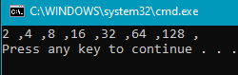

**Task No. 2:**

Write a program which takes input of an integer number and returns the sum of all numbers. i.e., if input is 3453 then the output should be 15 (3+4+5+3).

**Solution:**

int[] a = new int[5];

int sum = 0;

Console.WriteLine("ENTER NUMBER");

for (int i = 0; i < a.Length; i++)

{

a[i] = Convert.ToInt32(Console.ReadLine());

sum += a[i];

}

for (int i = 0; i < a.Length; i++)

{

Console.Write("SUM OF THE NUMBER:{0}({1}+{2}+{3}+{4}+{5})", sum, a[0], a[1], a[2], a[3], a[4]);

break;

}

Console.WriteLine();

**OUTPUT**:

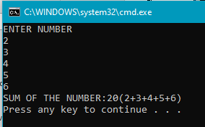

**Task No. 3:**

Write a program to calculate binomial coefficients of any given number using recursion.

**Solution:**

public static long nfact(long a)

{

if (a==0)

{

return 1;

}

return a * nfact(a - 1);

}

static void Main(string[] args)

{

long n, k,t;

long binomial;

Console.WriteLine("note n is greater than k");

Console.WriteLine("Enter the value of n");

n = Convert.ToInt64(Console.ReadLine());

Console.WriteLine("Enter the value of k");

k = Convert.ToInt64(Console.ReadLine());

binomial = nfact(n) / (nfact(k) * nfact(n - k));

Console.WriteLine("binomial coefficient:{0}",binomial);

}

**OUTPUT**:

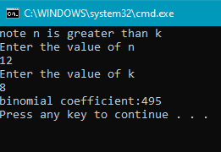

**Task No. 4:**

Calculation of number of moves for N number of disk in Tower of Hanoi problem using recursion.

**Solution:**

public static int moves(int disc)

{

if (disc==0)

{

Console.WriteLine("Enter Above Value");

return 0;

}

else if (disc == 1)

{

return 1;

}

else

{

return 2 * moves(disc - 1) + 1;

}

}

static void Main(string[] args)

{

Console.WriteLine("Enter No of discs");

int discs = int.Parse(Console.ReadLine());

Console.WriteLine("no of moves are : " + moves(discs));

}

**OUTPUT**:

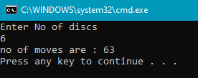

**Task No. 4:**

Write a program to calculate H.C.F of two numbers, using recursion.

**Solution:**

static int hcf(int a, int b)

{

// Everything divides 0

if (a == 0)

return b;

if (b == 0)

return a;

// base case

if (a == b)

return a;

// a is greater

if (a > b)

return hcf(a - b, b);

return hcf(a, b - a);

}

static void Main(string[] args)

{

int a , b;

Console.WriteLine("Enter the value of a");

a = Convert.ToInt32(Console.ReadLine());

Console.WriteLine("Enter the value of b");

b = Convert.ToInt32(Console.ReadLine());

Console.WriteLine("HCF of " + a + " and " + b + " is " + hcf(a, b));

}

**OUTPUT**:

